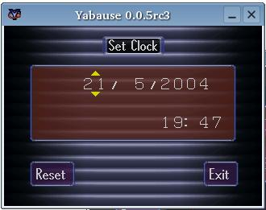
Yabause is a Sega Saturn emulator that currently runs on Linux and is being ported to Microsoft Windows and Mac OS X.
This project is at an early stage. Don't expect to play commercial games on your PC.

